2018 Office: 759-2122 Evening Water Emergencies Only - Br. Hugh 759-7205 xt 207
November
Sunday | Monday | Tuesday | Wednesday | Thursday | Friday | Saturday
 | Sign up for Activities in “green” in the Multipurpose Room |  |  | 1 Feast of All Saints  8:30 Mass  Guild Meeting-Noon  3:00 Exercise  Pinochle 6:30 VL | 2 Chapel 11:00  Daisy Visits @ 10  Craft Club 2:00 VL | 3  BINGO – 7:00
4 Mass 8:30  Pinochle 6:30 VL | 5 Chapel 11:00  1:00 Exercise  2:00 Word Build  6:30 Bflo Rock n Roll  Montabaur Heights  Transportation available | 6 Rosary/Chapel 8:30  1:00 Exercise  Pinochle 6:30 VL | 7 Chapel 11:00  BINGO – 7:00 | 8  10:00 Health & Spirituality  3:00 Exercise  Evening Prayer 6:00  Pinochle 6:30 VL | 9 Chapel 11:00  Casino Bus  Craft Club 2:00 VL | 10
11 Mass 8:30  Pinochle 6:30 VL | 12 Chapel 11:00  1:00 Exercise  6:30 Bflo Naval Park  presentation  Montabaur Heights Transportation available | 13 Rosary/Chapel 8:30  1:00 Exercise  Pinochle 6:30 VL | 14 Chapel 11:00  SPECIAL! Casino Bus  10:00  Coffee Hour – 1:00  BINGO – 7:00 | 15 11-12:00 Wellness during the Holidays – Montabaur Heights  12:00 Gift Shop Sale Montabaur Heights  3:00 Exercise  5:30 Dinner Party &  Entertainment w/  Tom Bender  Pinochle 6:30 VL | 16 Chapel 11:00  Craft Club 2:00 VL | 17  BINGO – 7:00
18 Mass 8:30  Pinochle 6:30 VL | 19 Chapel 11:00  1:00 Exercise  1:00 Independent Health & Medicare Enrollment  2:00 Word Build | 20 Rosary/Chapel 8:30  1:00 Exercise  Pinochle 6:30 VL | 21 Chapel 11:00  BINGO – 7:00 | 22 Mass 9:30  Sacred Heart Home  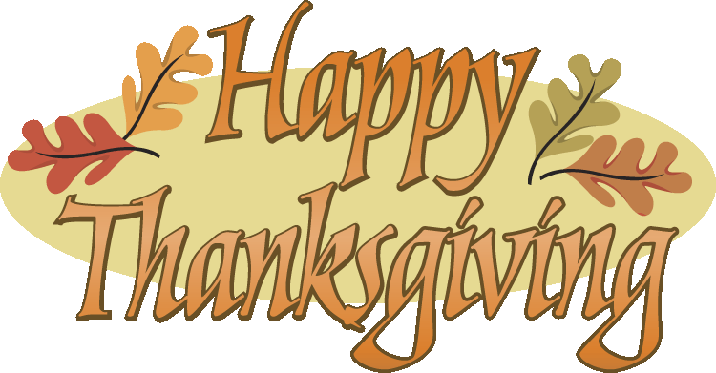 | 23 Chapel 11:00  Casino Bus  Craft Club 2:00 VL | 24
25 Mass 8:30  Pinochle 6:30 VL | 26 Chapel 11:00  1:00 Exercise | 27 Rosary/Chapel 8:30  1:00 Exercise  Pinochle 6:30 VL | 28 Chapel 11:00  BINGO – 7:00 | 29  3:00 Exercise  Pinochle 6:30 VL | 30 Chapel 11:00  Casino Bus – Batavia Downs  Craft Club 2:00 VL | “..to be old and wise, you must first be young and stupid….”

