
BROTHERS OF MERCY NURSING & REHABILITATION CENTER ACTIVITY CALENDAR
SUNDAY  January | MONDAY | TUESDAY | WEDNESDAY | THURSDAY | FRIDAY | SATURDAY
 | 2021 |  | 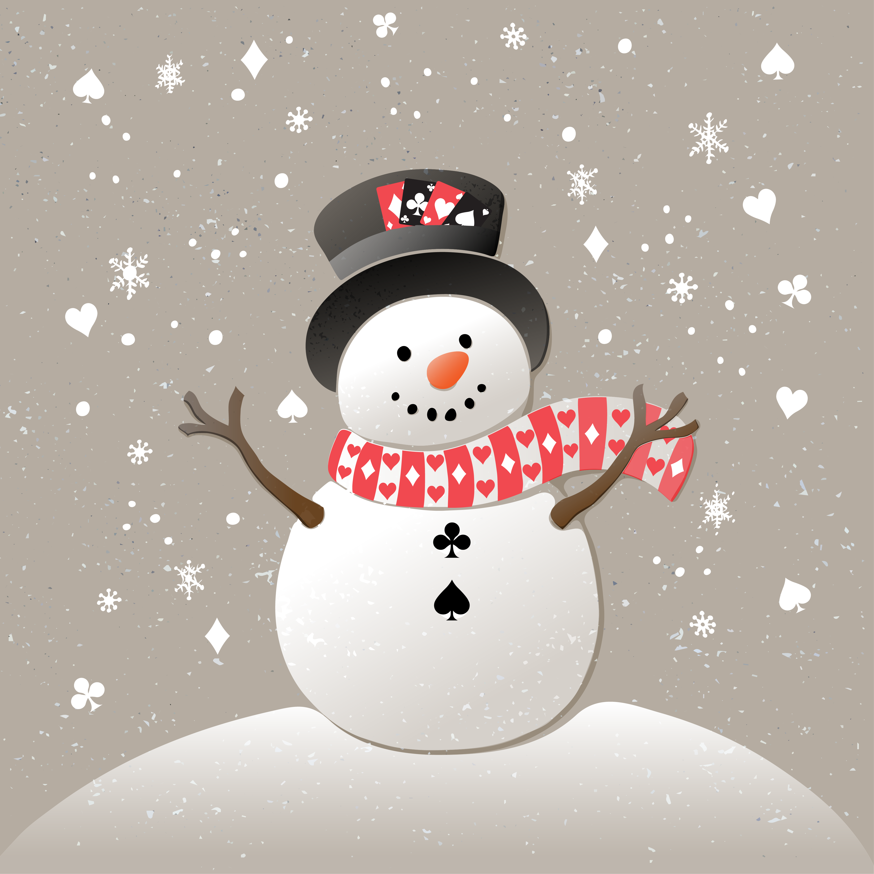 |   8:00 AM  &  12:00 Noon  Daily  Catholic  Mass  (EWTN)  Channel 50 | 1  9:15 Morning Visits (All Units)  10:30 Short Story Cart (All Units)  2:00 New Year’s Snack    Cart (All Units)  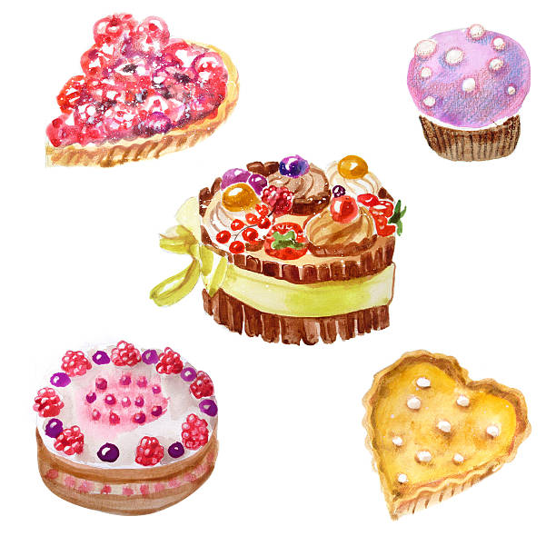   | 2  9:15 Morning Visits (All Units)  10:00 Saturday Coffee Cart    (All Units)  2:00 Puzzle Cart!  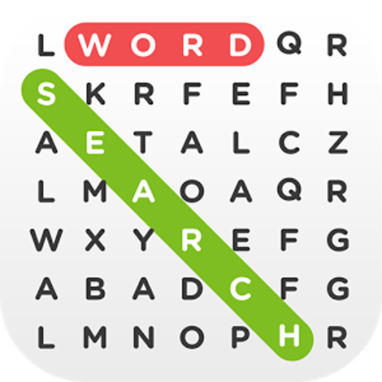  (1:1 / All Units)
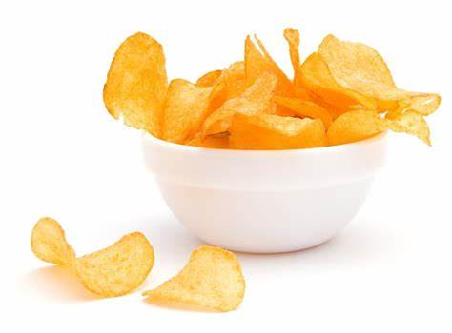  3  10:15 Morning Visits  (All Units)  1:00 Bills vs Dolphins  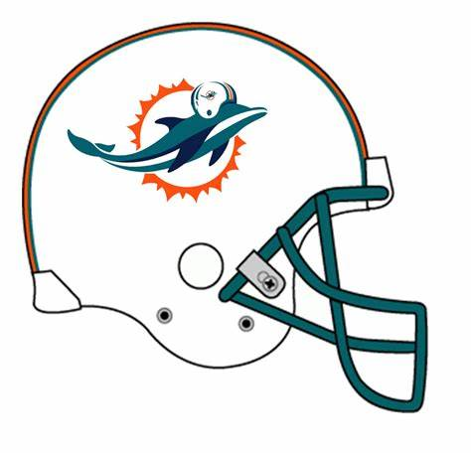  w/snacks      (CBS) | 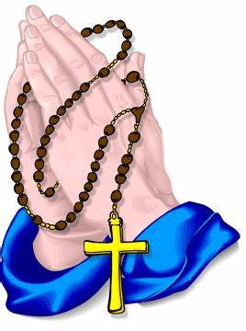  4  9:30 Rosary & Prayer  Service (Channel 97)  10:00 Juice and Story Cart  1:30 Virtual Bingo  (Channel 97)  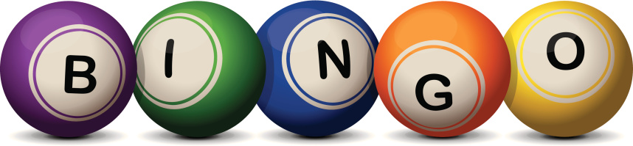  6:30 Moctail Cart (All Units) | 5  9:15 Morning Visits (All Units)  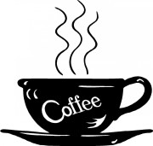  9:30 Coffee Cart (All Units)  1:30 Virtual Bird Videos  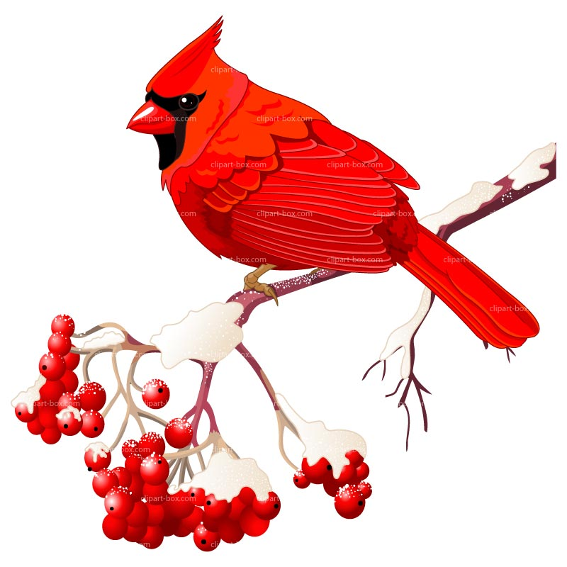  (Channel 97)  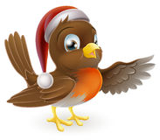  National Bird Day | 6  9:15 Morning Visits (All Units)    10:00 Exercise Video  (Channel 97)    10:00 Exercise Video  1:30 Interfaith Service (Ch. 97)  3:00 Virtual Video of Harp  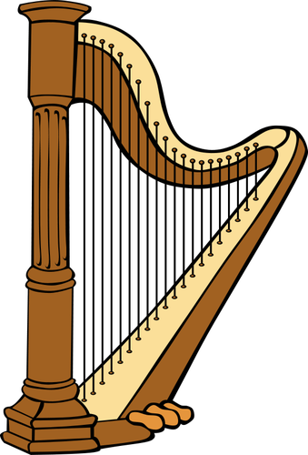  Music (Channel 97)   | 7  9:30 Rosary & Prayer  Service (Channel 97)  10:00 Activity Cart! (All Units)  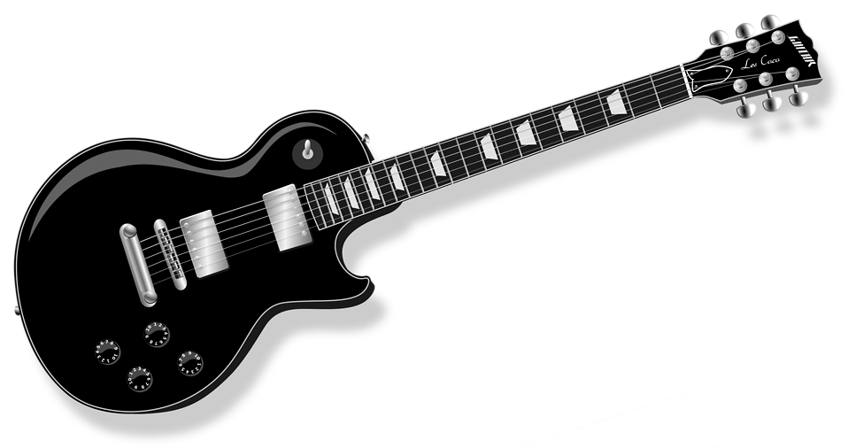  2:00 Entertainment  By Brian Beaudry  (Channel 97)  6:30 Snack Cart (All Units) | 8  9:15 Morning Visits (All Units)  10:30 Short Story Cart (All Units)  2:00 Jell-O Cart (All Units)   | 9  9:15 Morning Visits (All Units)  10:00 Saturday Coffee Cart  (All Units)  2:00 Puzzle Cart!    (1:1 / All Units)  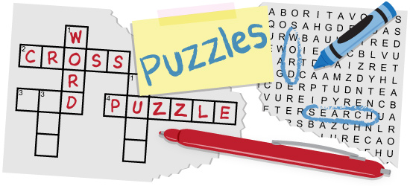
10  9:15 Morning Visits  (All Units)  2:00 Ice Cream Cart    (All Units)   | 11  9:30 Rosary & Prayer  Service (Channel 97)  10:00 Card Writing!!! (All Units)  1:30 Virtual Bingo (Channel 97)  6:30 Moctail Cart (All Units)   | 12  9:15 Morning Visits (All Units)  9:30 Coffee Cart (2E/2W)  2:00 Tea & Cookie  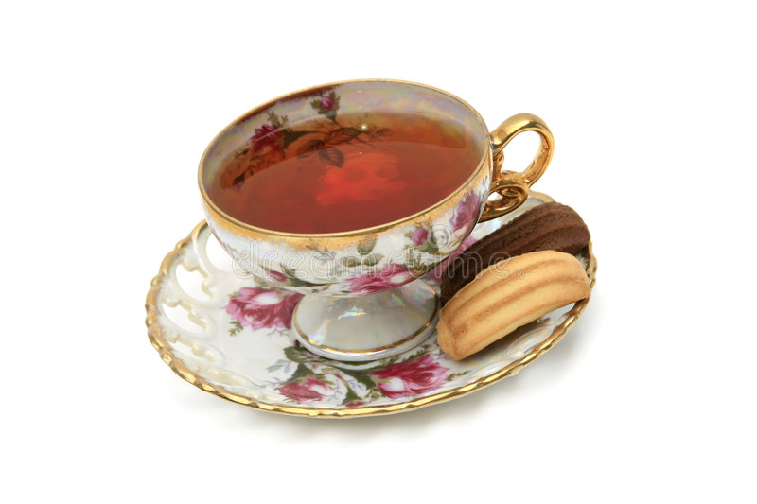  Cart (All Units)  National Hot Tea Day | 13  9:15 Morning Visits (All Units)  10:00 Exercise Video  (Channel 97)  1:30 Interfaith Service (Ch. 97)    3:00 Virtual Tour of Switzerland    (Channel 97) | 14  9:30 Rosary & Prayer  Service (Channel  10:00 Activity Cart! (All Units)  2:00 Birthday Party  Cart! (All Units)    6:30 Snack Cart (All Units) | 15  9:15 Morning Visits (All Units)  10:30 Short Story Cart (All Units)  2:00 Soup Cart!!  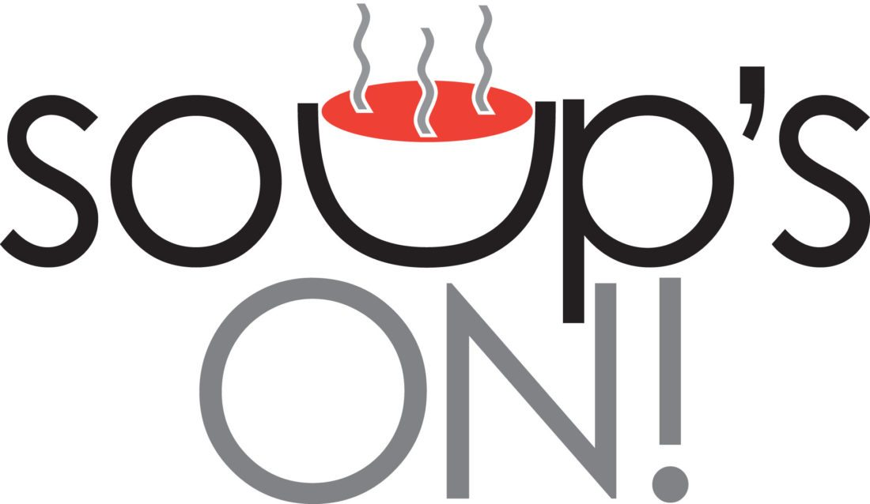  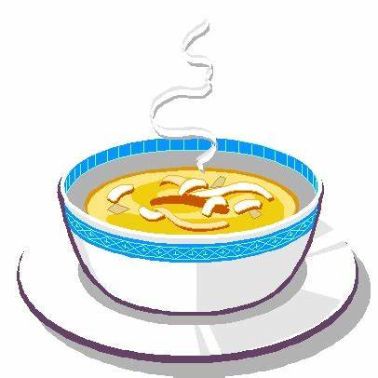 | 16  9:15 Morning Visits  10:15 Saturday Coffee Cart  (1:1 / All Units)  2:00 Activity Cart!! (All Units)    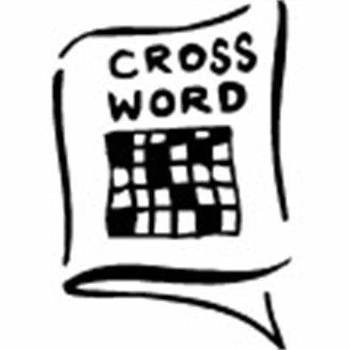
  17  10:15 Morning Visits  (All Units)  2:00 Cheese & Cracker cart  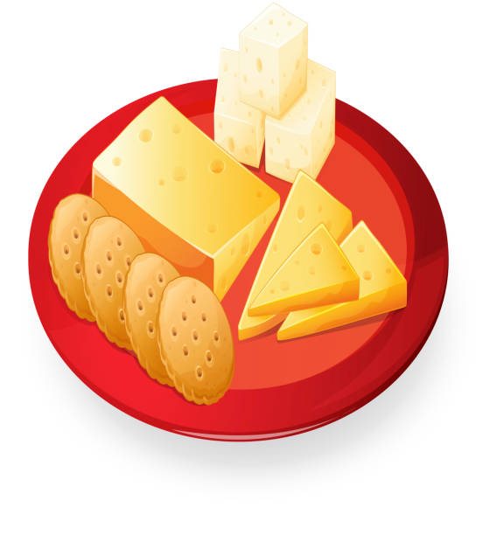  (All Units) | 18  9:30 Rosary & Prayer  Service (Channel 97)  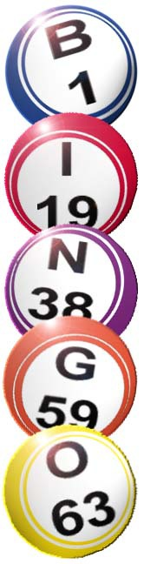  10:30 Activity Cart (All units)  1:30 Virtual Bingo  (All Units)  6:30 Moctail Cart (All Units)  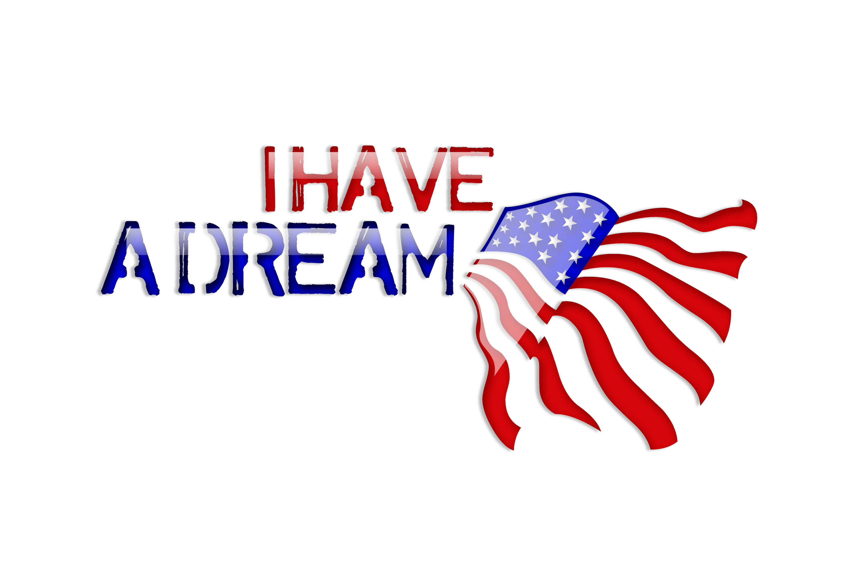  Martin Luther King Jr. Day | 19  9:15 Morning Visits (All Units)  9:30 Coffee Cart (2E/2W)  2:00 Popcorn Cart  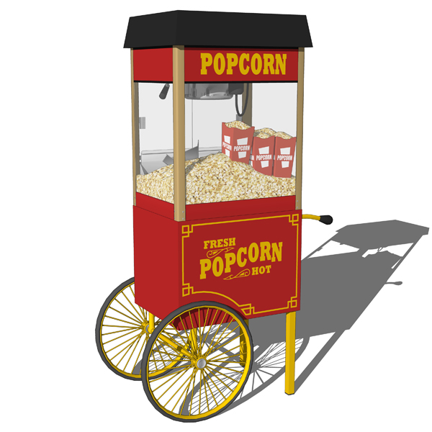  (All Units)    National Popcorn Day | 20  9:15 Morning Visits (All Units)  10:00 Exercise Video  (Channel 97)  1:30 Interfaith Service (Ch. 97)  3:00 Virtual Tour of    Penguins (Channel 97)  Penguin Awareness Day | 21  9:30 Rosary & Prayer  Service (Channel 97)  10:15 Activity Cart! (All Units)  2:00 Entertainment By  Brian Beaudry  (Channel 97)    6:45 M  6:30 Snack Cart (All Units) | 22  9:15 Morning Visits (All Units)  10:30 Short Story Cart (All Units)  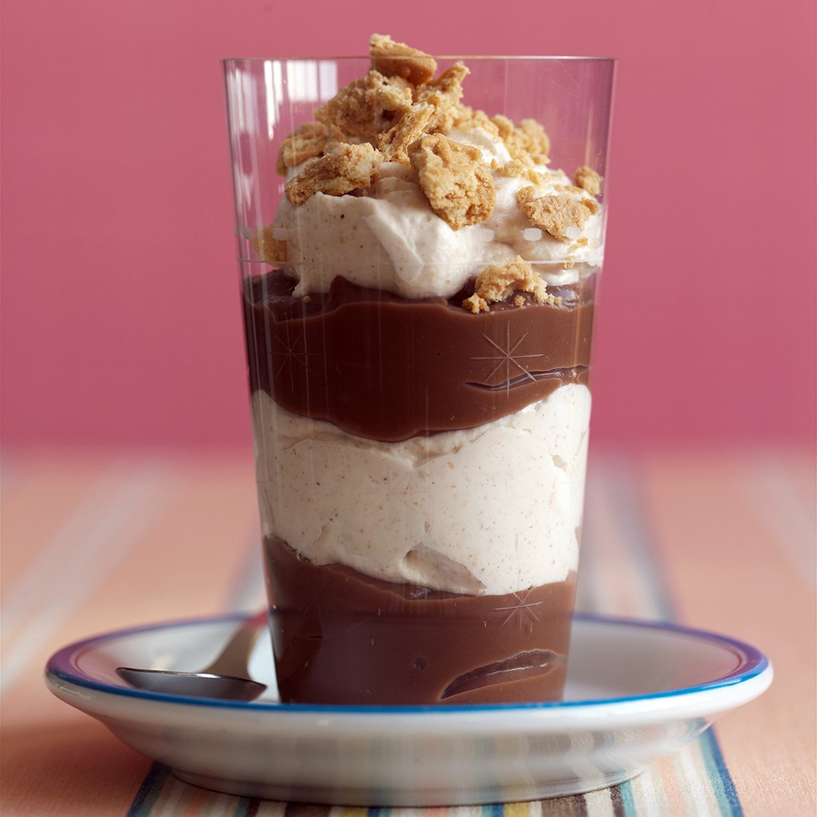  2:00 Peanut Butter Parfait!! | 23  9:15 Morning Visits  10:15 Saturday Coffee Cart  (1:1 / All Units)  2:00 Card Writing!!  (All Units)      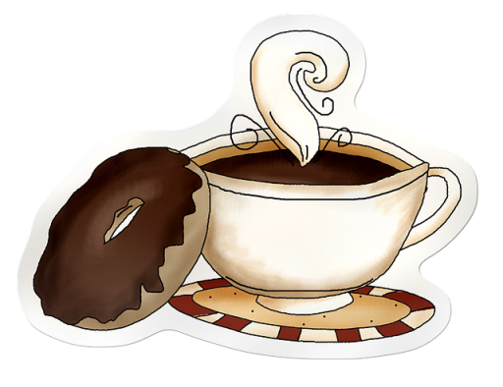  National Hand Writing Day
24  10:15 Morning Visits  (All Units)  2:00 Ice Cream Cart  (All Units)  -----------------------------------------------------------  31  10:15 Morning Visits  (All Units)  2:00 Cheese & Cracker Cart  (All Units) | 25  9:30 Rosary & Prayer  Service (Channel 97)  10:15 Activity Cart (All Units)  1:30 Virtual Bingo (Channel 97)  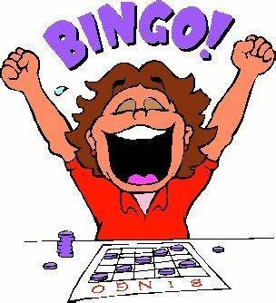  6:30 Moctail Cart (All Units) | 26  9:15 Morning Visits (All Units)  9:30 Coffee Cart (2E/2W)  2:00 Joke Day (Channel 97)  3:00 Virtual video of Australia  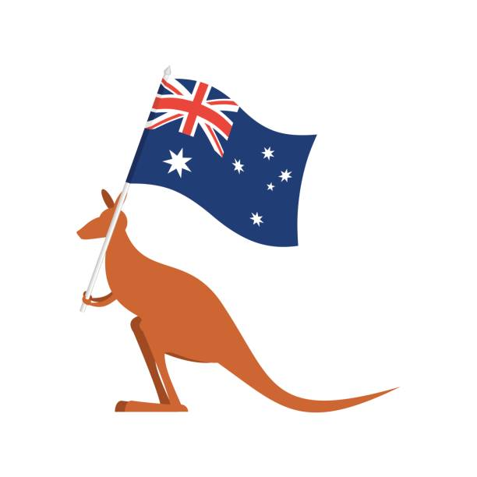  National Australia day | 27  9:15 Morning Visits (All Units)  10:00 Exercise Video  (Channel 97)  1:30 Interfaith Service  (Channel 97)  2:00 Chocolate cupcakes/  Virtual Tour of Hershey    (All Units/Channel 97)  National Chocolate Cake day | 28  9:30 Rosary & Prayer  Service (Channel 97)    10:15 Activity Cart! (All Units)  2:00 Yogurt  Cart (All Units)  6:30 Snack Cart (All Units) | 29  9:15 Morning Visits (All Units)  10:15 Short Story Cart  (Channel 97)  2:00 Puzzle cart (All Units)  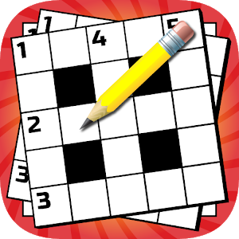  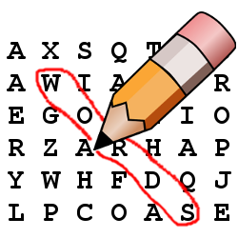  National Puzzle Day | 30  9:15 Morning Visits  10:15 Coffee Cart (1:1 / All Units)  2:00 Activity Cart  (All Units)  

